# User Manual

The manual is divided into 2 sections, the first section teaches you how to construct environment for the source code to run. The second section teaches you how to use the program.

Section 1 Setting Environment

Step1: Build path for java project

Before compiling and running the source code, **pdfbox, jdbc and postgreSQL** needs to be downloaded, installed and properly added to the module path in java project.

The following links provide download and detailed instruction on how to configure each component:

Pdfbox: <https://www.tutorialspoint.com/pdfbox/pdfbox_reading_text.html>

Jdbc: <https://jdbc.postgresql.org/download.html>

PostgreSQL: <https://www.tutorialspoint.com/postgresql/postgresql_java.htm>

After proper setting, your Modulepath for the java project in which you want to run the source code should look like this:

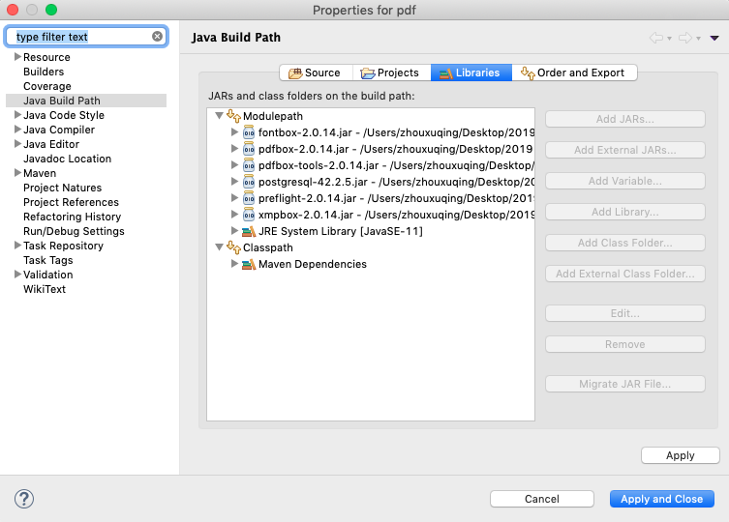

Step2: Create local Database on PostgreSQL

Run postgreSQL, make sure the server is localhost, the portal is 5432 as the following picture.

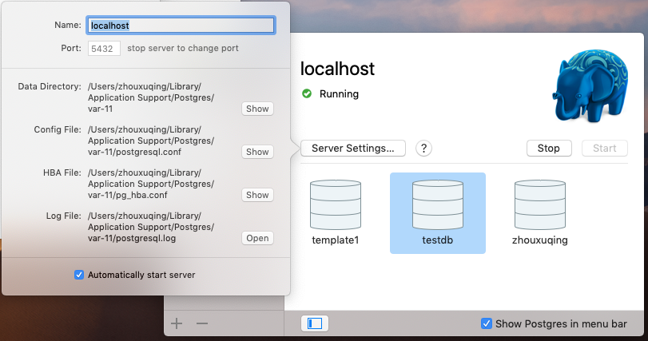

Enter the Command line interface of postgreSQL:

1. Create a database named ‘testdb’ with:



2. Change directory to your ‘testdb’ with:



3. Create 2 tables called ‘name’ and ‘skill’ with:



if the table is properly created, you are supposed to get the following by typing \d:

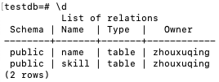

Step 3: Copy and run the source code

The source code should be copied into the java project in which you set environment, and looks like this:

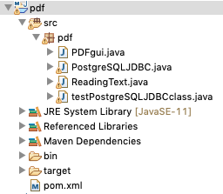

Then，you can run the source code. If everything goes correctly, you will see an interface popped out like this:

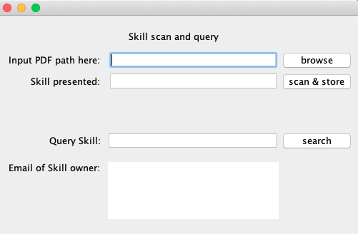

Section 2: Use skill scan and query system

You can simply copy the file path of the target resume into the box as the following picture and press ‘scan & store’ button.

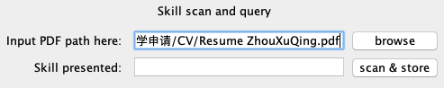

You will see the skill presented in the Resume be listed and a message reporting you that the email and the skills are properly stored into the database:

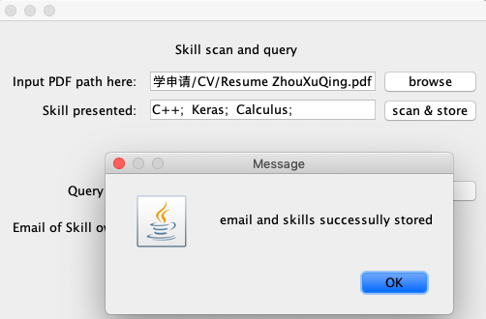

If you are curious about how the data is stored, you can connect to the database ‘testdb’ and input:

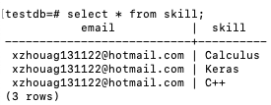

You will get the following information shown on the screen. It can be seen that the email presented in the resume and the skill is properly stored in the database.



Then you can use the retrieve function in the program to search for the email of the skill owner.

Simply type in the skill you want to search and press search in the following

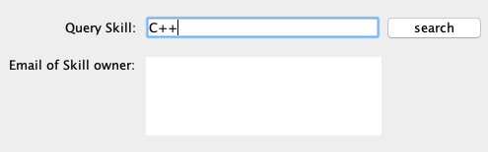

you will get the result like this：

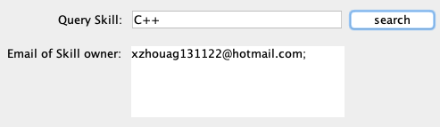

When the database stores more candidate, it will show all the candidates that present the skill.